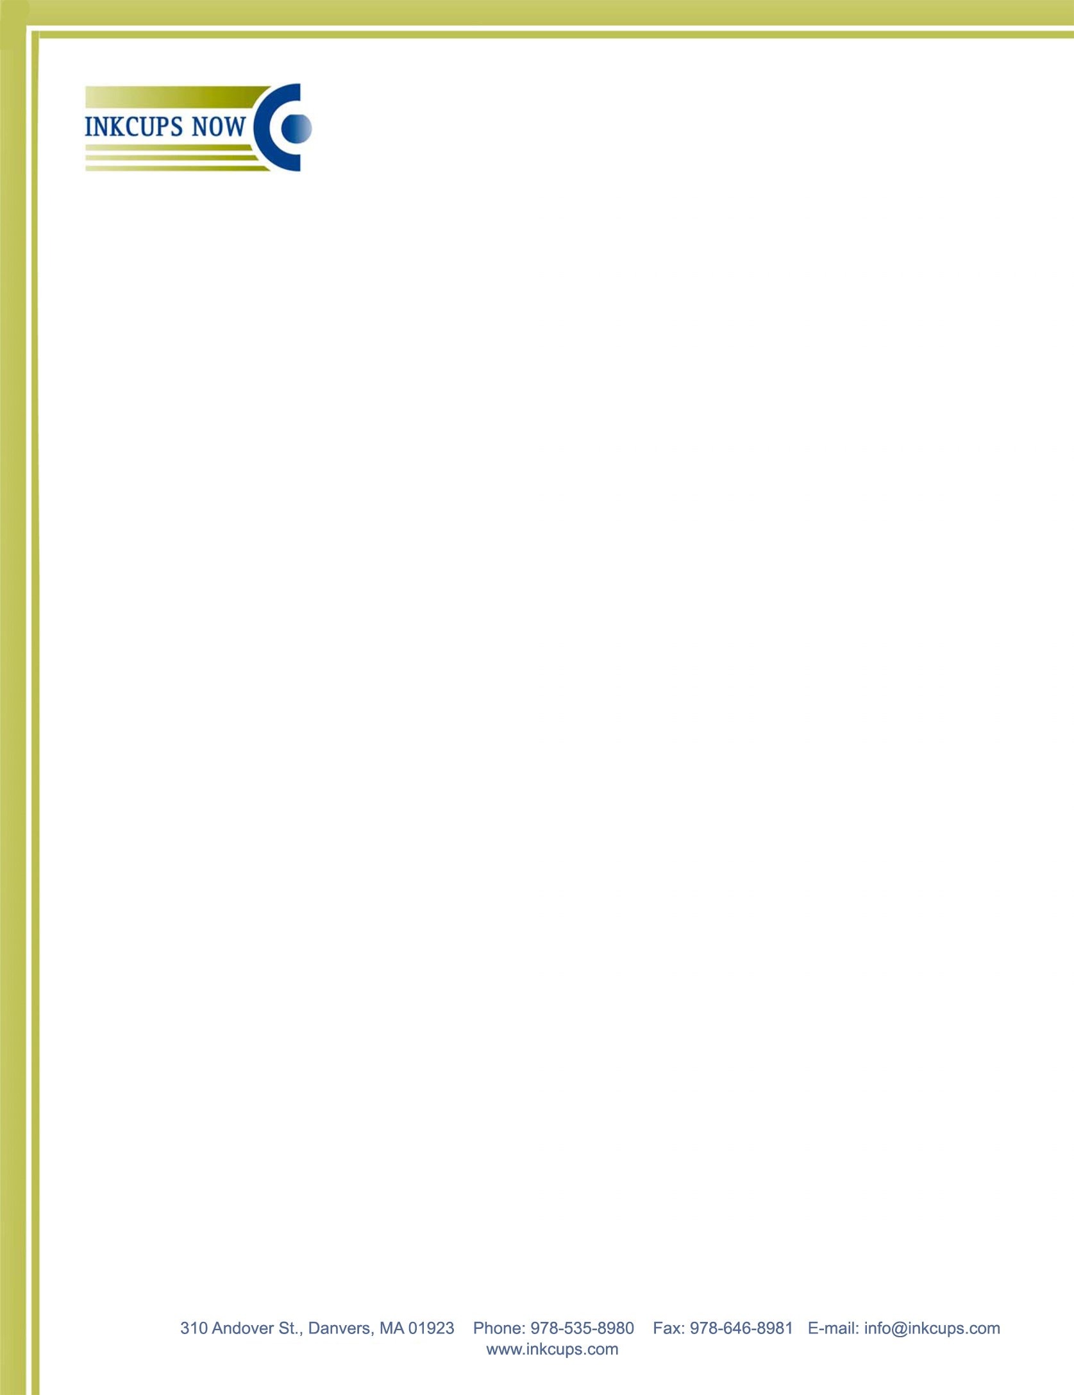
INK TESTING

Hint: you can type in the grey fields, click to select a dropdown item and check/uncheck boxes

Test done by:
Request from ICN salesman:
Date submitted:
Date tested: | Date shipped:

Customer Information:

Company: |  | Contact:
Existing customer New customer
Phone: | E-mail: |  | Fax:
Shipping address:

UPS or FedEx account #:
PO # (optional):

Application:

Pad printing Screen printing
Product description:
Substrate:
Current inks:
Pre-treatment acceptable to customer: Yes No | Drying method acceptable to customer:
Use of hardener acceptable to customer: Yes No | Required abrasion resistance level:
Customer needs printed samples shipped back: Yes No

Testing:

Inks | Color | Pre-treatment | Scratch test | Tape test | Opacity

Recommendation:

Ink:
Comments:

